SUMMERVILLE CREDIT UNION · CONSOLIDATED MEMBER GUIDE · CSUM-28 of 30
Device Management & Trusted Devices

Module: nFinia Digital Banking > More > Personal Information > Devices
Sources: Summerville Reports Series A (36 docs) + Series B (25 docs) | Features: nFinia Documentation Features Spreadsheet
01 PRODUCT SUMMARY

Device Management allows Summerville Credit Union members to view and manage all devices registered as trusted for their digital banking account. A device becomes trusted when a member completes a full login (username + password + OTP) and selects 'Remember this device' during the OTP step, allowing future logins from that device to bypass the OTP verification.
The Devices tab shows all trusted devices with their device name, OS, last login date, and trust status. Members can remove any device from the trusted list — which immediately requires full OTP authentication on the next login from that device. This is essential for decommissioning old phones and for security response after a suspected compromise.
Trusted Device Approval Required is an enhanced security mode available for some account types, where any new device login requires explicit approval from an already-trusted device before the session is established.

At a Glance

Attribute | Detail
Module | More > Personal Information > Devices
Trusted Device | Device where OTP step is bypassed after initial trust
Trust Action | Set during login by checking 'Remember this device'
Revoke Trust | Removing a device from the list re-requires OTP on next login
Enhanced Mode | Trusted Device Approval Required — new logins require existing device approval
Related Reports | CSUM-22 (Personal Information), CSUM-01 (Login & Auth), CSUM-25 (Password & MFA)

02 KEY USE CASES

Use Case | Who Uses It | What They Do | Business Value
Review Trusted Devices | Members auditing account security | Open Devices tab to see all registered trusted devices | Confirms which devices can log in without OTP, enabling security audit
Remove Old Phone | Members replacing their device | Click remove on the old device entry | Immediately revokes OTP bypass for the decommissioned device
Revoke After Security Event | Members who suspect account compromise | Remove ALL trusted devices to force OTP on every login | Nuclear option that resets all trusted sessions, securing the account
Approve New Device Login | Members with Trusted Device Approval mode | Approve a new login attempt from an existing trusted device | Enhanced security requiring confirmation from a known good device

03 STEP-BY-STEP GUIDE

Navigation: Dashboard > More > Personal Information > Devices tab.

Step 1 — Start from Dashboard
The member begins at the Dashboard after logging in. The Dashboard displays all account balances, upcoming payments, quick-action tiles, and the top navigation bar with links to Accounts, Move Money, and More.
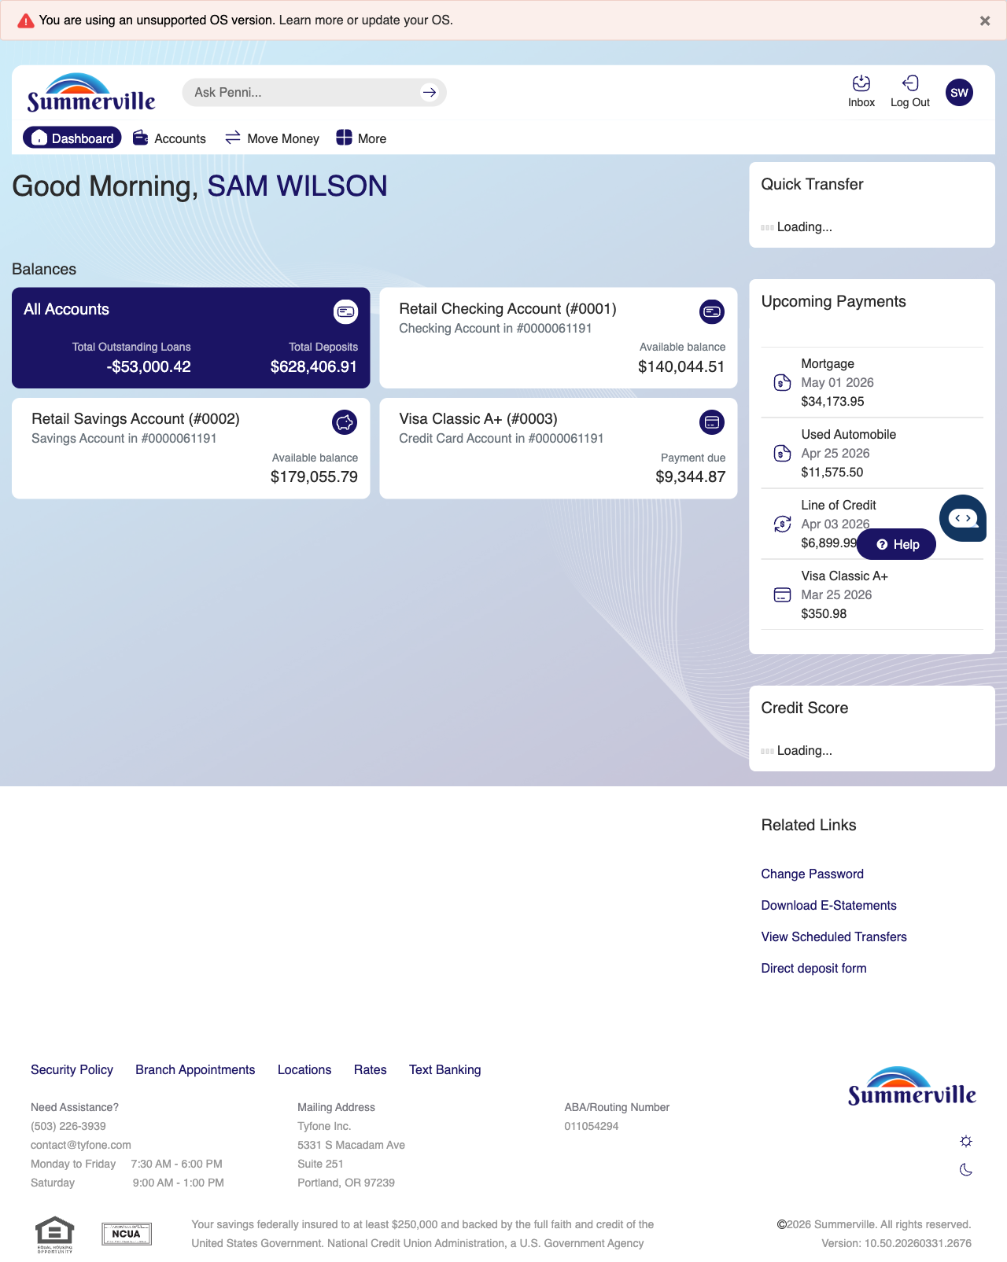
Step 1: Start from Dashboard

Step 2 — Open the More Menu
The member clicks ‘More’ in the top navigation bar. The More options panel expands to show additional features: Check Deposit, User ID and Password, eDocuments, Account Alerts, General Alerts, Password, Forms, One-Time Passcode, Skip A Pay, Do-Not-Disturb, Manage Devices, My Insights, Alert Settings, Recent Activities, and Card Services.
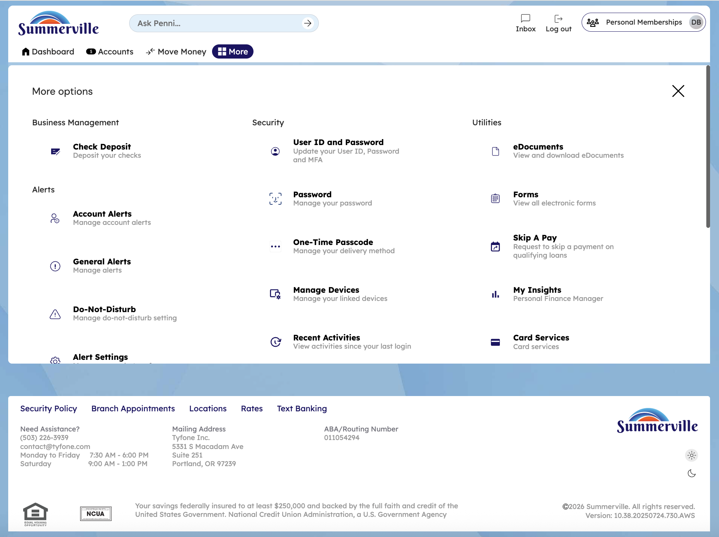
Step 2: More Menu

Step 3 — Navigate from Dashboard to Devices
The Account Overview page shows a detailed list of registered devices with columns for device type, date registered, and action buttons for managing each device.
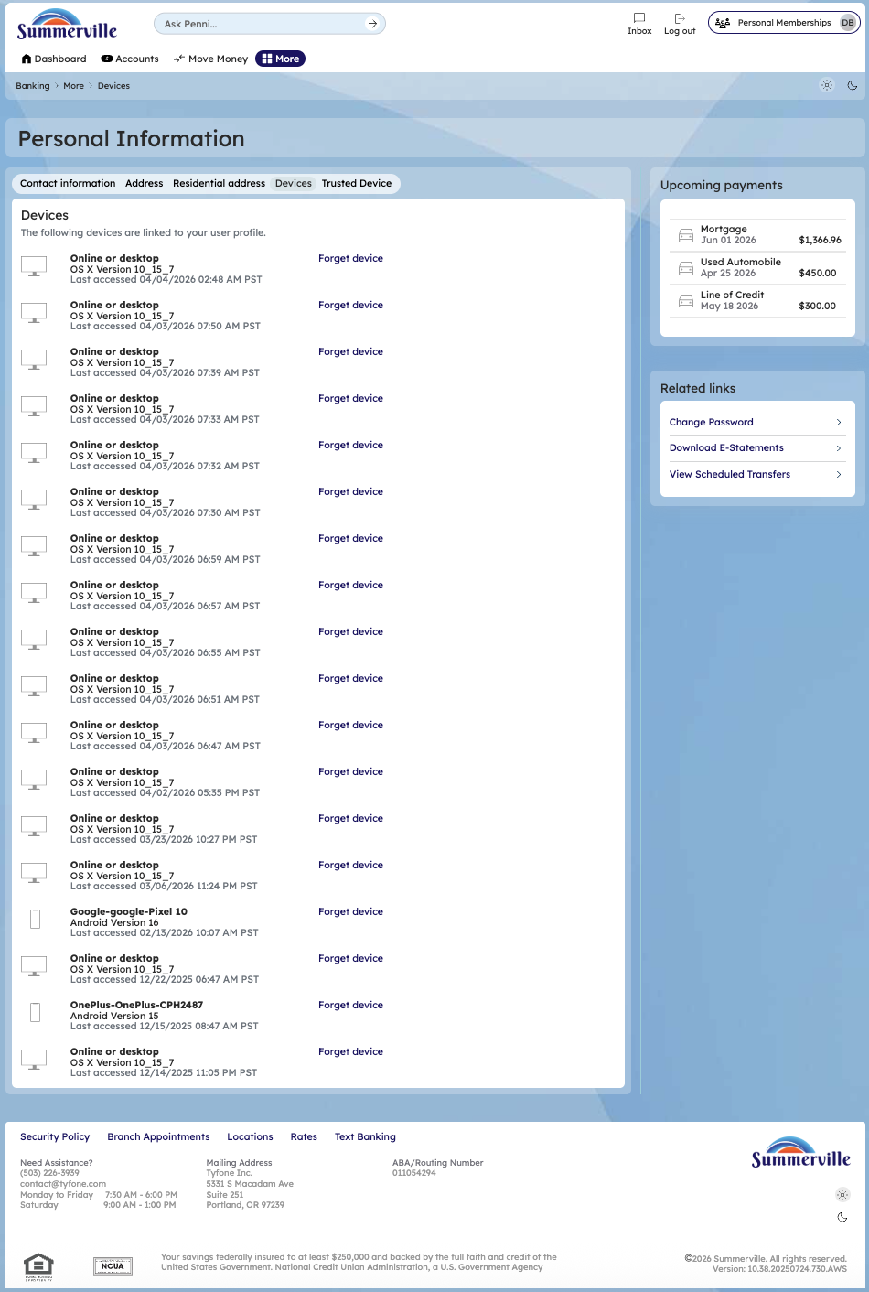

Step 4 — Remove a Trusted Device
A confirmation modal asks 'Are you sure you want to forget this device?' with Cancel and Proceed buttons for the member to confirm or cancel the device removal.
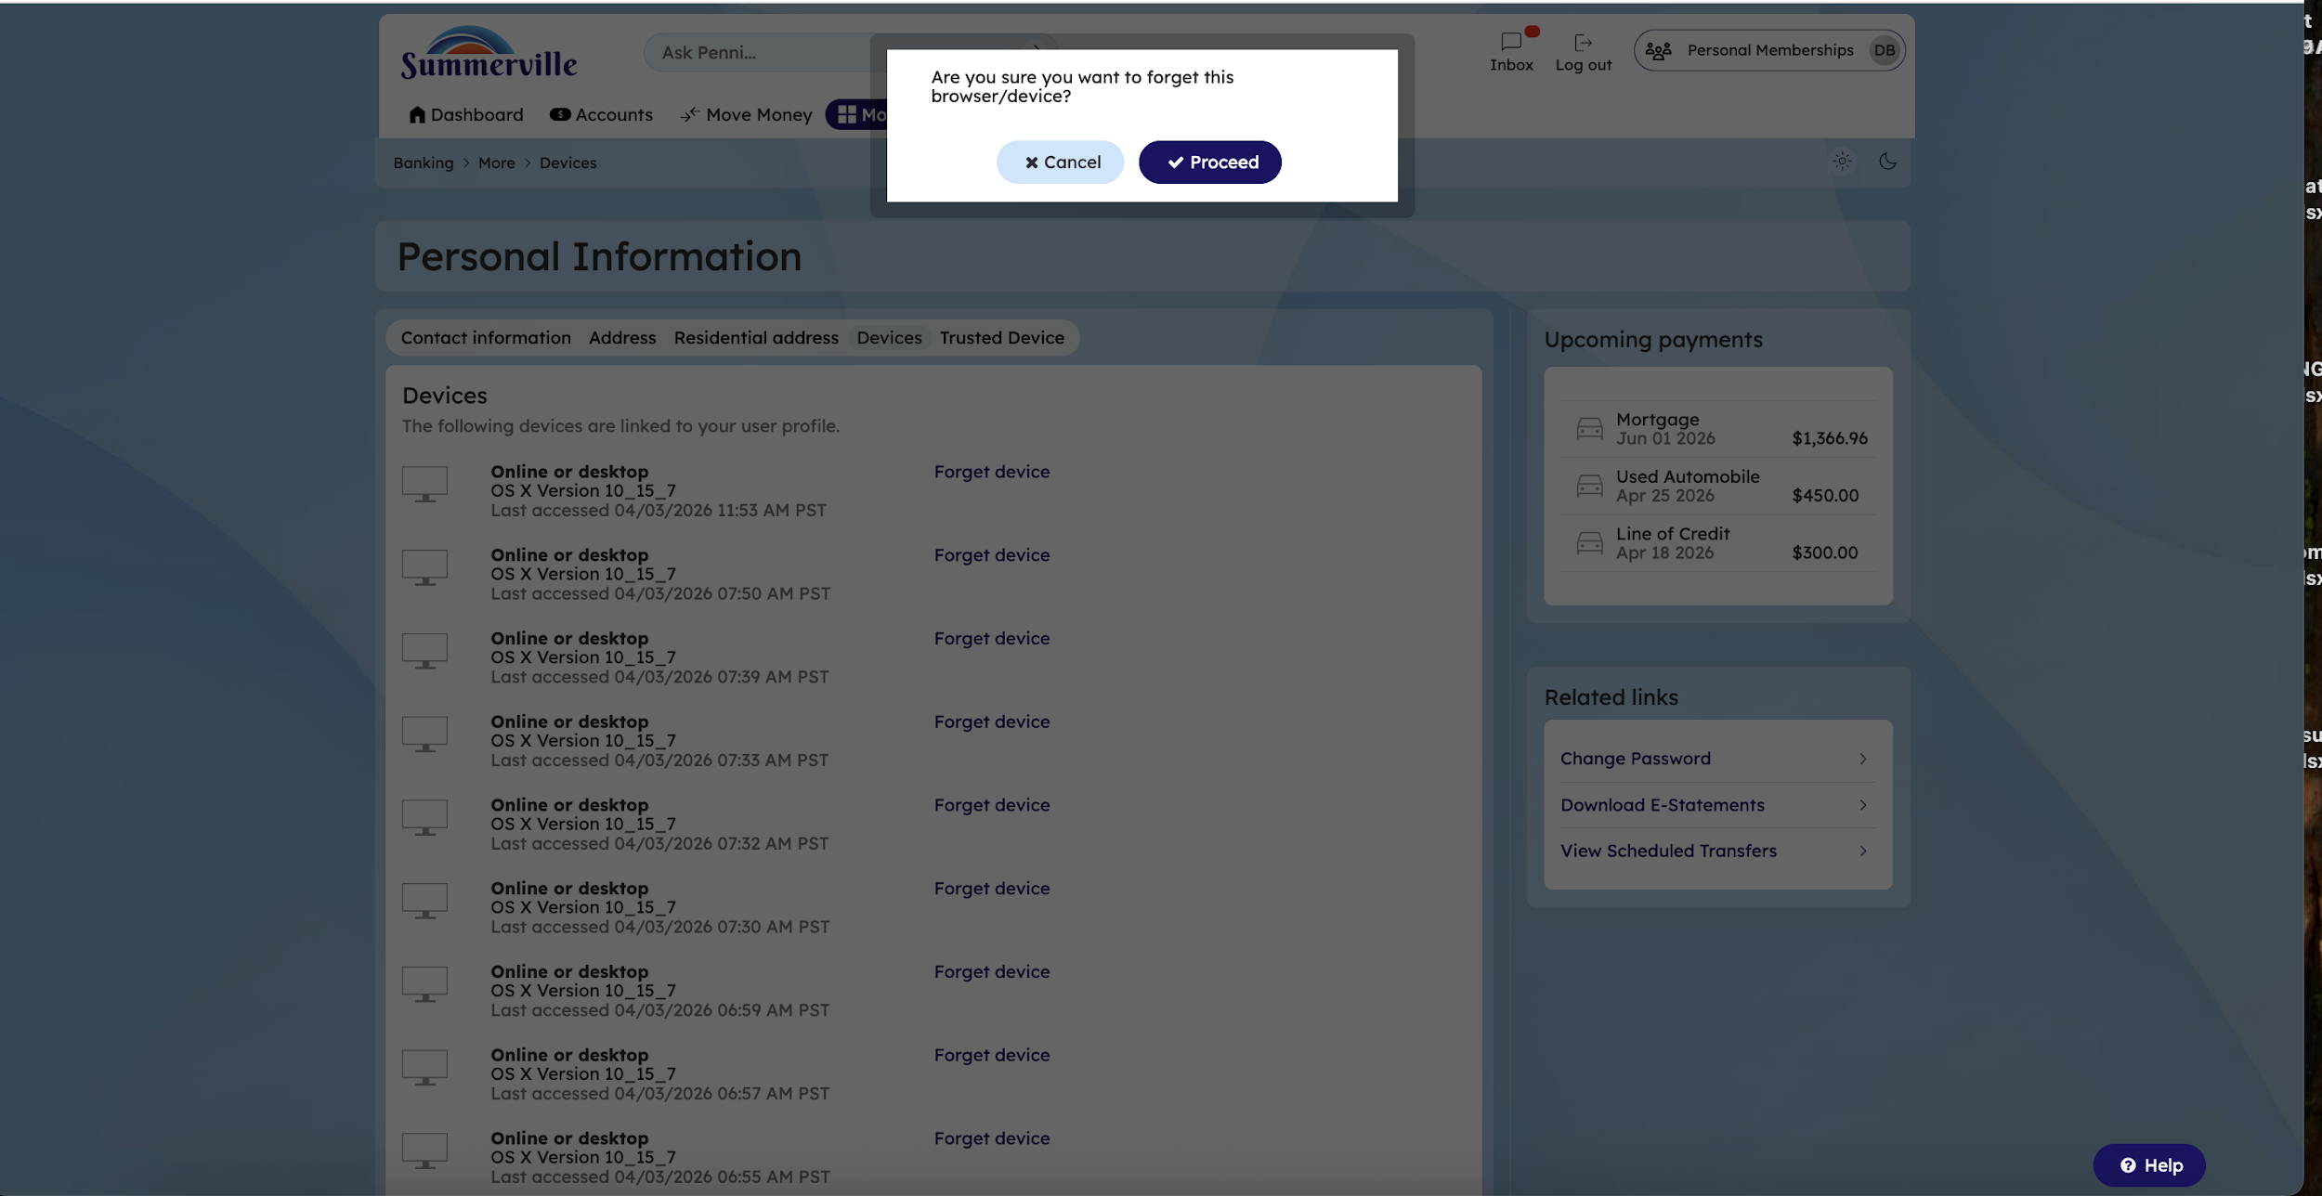
Step 5: Remove a Trusted Device

